FADING OF AN LED USING ARDUINO
Date:

Aim:
To interface an LED with Arduino and to write a program to make the LED fade.

Components required:
- PC or laptop
- Arduino UNO
- 220 resistor
- LED
- Breadboard
- Connecting wires
Software required:
- Arduino IDE
Connections:
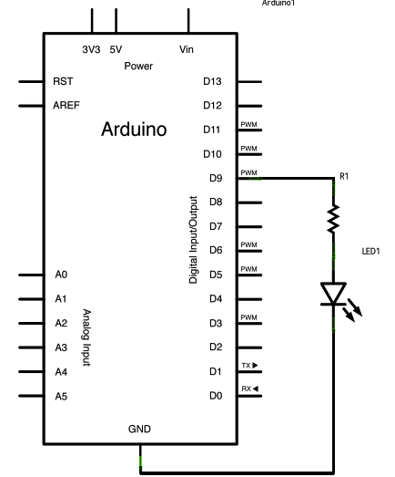
- Connect the longer leg of the LED, that is the anode, to the digital pin 9 in the Arduino, through a 220 resistor.
- Connect the shorter leg of the LED, that is the cathode, to the ground (GND) pin on the Arduino.
Procedure:
- Connect the components on a breadboard as mentioned above and connect the Arduino to the PC/laptop.
- Open Arduino IDE and open a new editor.
- Enter the required code save it as a “ino” file.
- In the “Tools” menu go to the “Port” tab and select the appropriate port.
- Upload the program into the Arduino and verify the output.
Program:
int led = 9; // the PWM pin the LED is attached to
int brightness = 0; // how bright the LED is
int fadeAmount = 5; // how many points to fade the LED by
// the setup routine runs once when you press reset:
void setup() {
// declare pin 9 to be an output:
pinMode(led, OUTPUT);
}
// the loop routine runs over and over again forever:
void loop() {
// set the brightness of pin 9:
analogWrite(led, brightness);
// change the brightness for next time through the loop:
brightness = brightness + fadeAmount;
// reverse the direction of the fading at the ends of the fade:
if (brightness <= 0 || brightness >= 255) {
fadeAmount = -fadeAmount;
}
// wait for 30 milliseconds to see the dimming effect
delay(30);
}

Result:
A program has been written to make the LED connected to an Arduino fade and the output verified.

